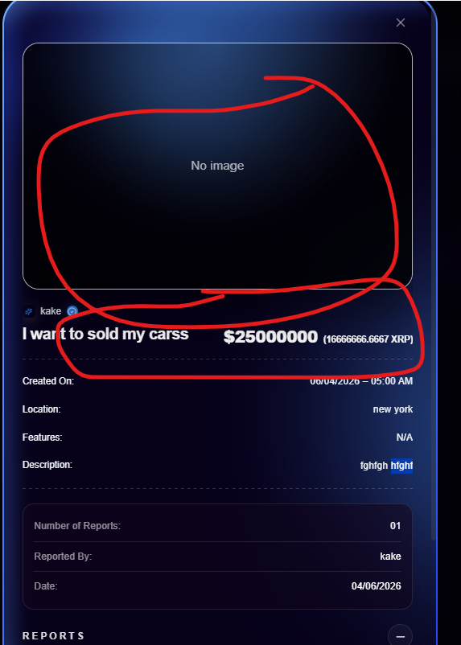
On Report Listing Details page, Different section from figma

